Parallel and MultiThreaded Programming

CSYE 7215

Homework 10

Due: December 5, 2020

Put all your C/C++, compiled class files and documentation into zip file named Homework9.zip and submit it via the dropbox on canvas before the END of due date. Put your name on all files. There will be a short quiz on this assignment.

1. Write Mutex lock mechanism to protect two Threads in this C++ Posix program:

<http://www.yolinux.com/TUTORIALS/LinuxTutorialPosixThreads.html>

🡪Mutual exclusion lock will block access to variables by other threads. This enforces exclusive access by a thread to a variable or set of variables.

🡪In give program we are trying to increment the counter variable using multiple threads

🡪If run the program without mutex lock the counter would be 1 as both the thread will not get the updated value of counter.

Possible execution sequence without mutex (assuming both thread are running concurrently)

**Thread 1 🡪 counter (value 0) 🡪counter++ ( value 1 )**

**Thread 2 🡪 counter (value 0) 🡪counter++ ( value 1 )**

🡪While using mutex lock it will make sure that only 1 thread can update the value of counter and mean while other thread will be blocked until it gets available.

🡪Hence we can see in the output that we always gets updated counter value

pthread_mutex_t mutex1 = PTHREAD_MUTEX_INITIALIZER;  
int counter = 0;

pthread_mutex_lock( &mutex1 );  
counter++;  
printf("Counter value: %d\n",counter);  
pthread_mutex_unlock( &mutex1 );

**output**:

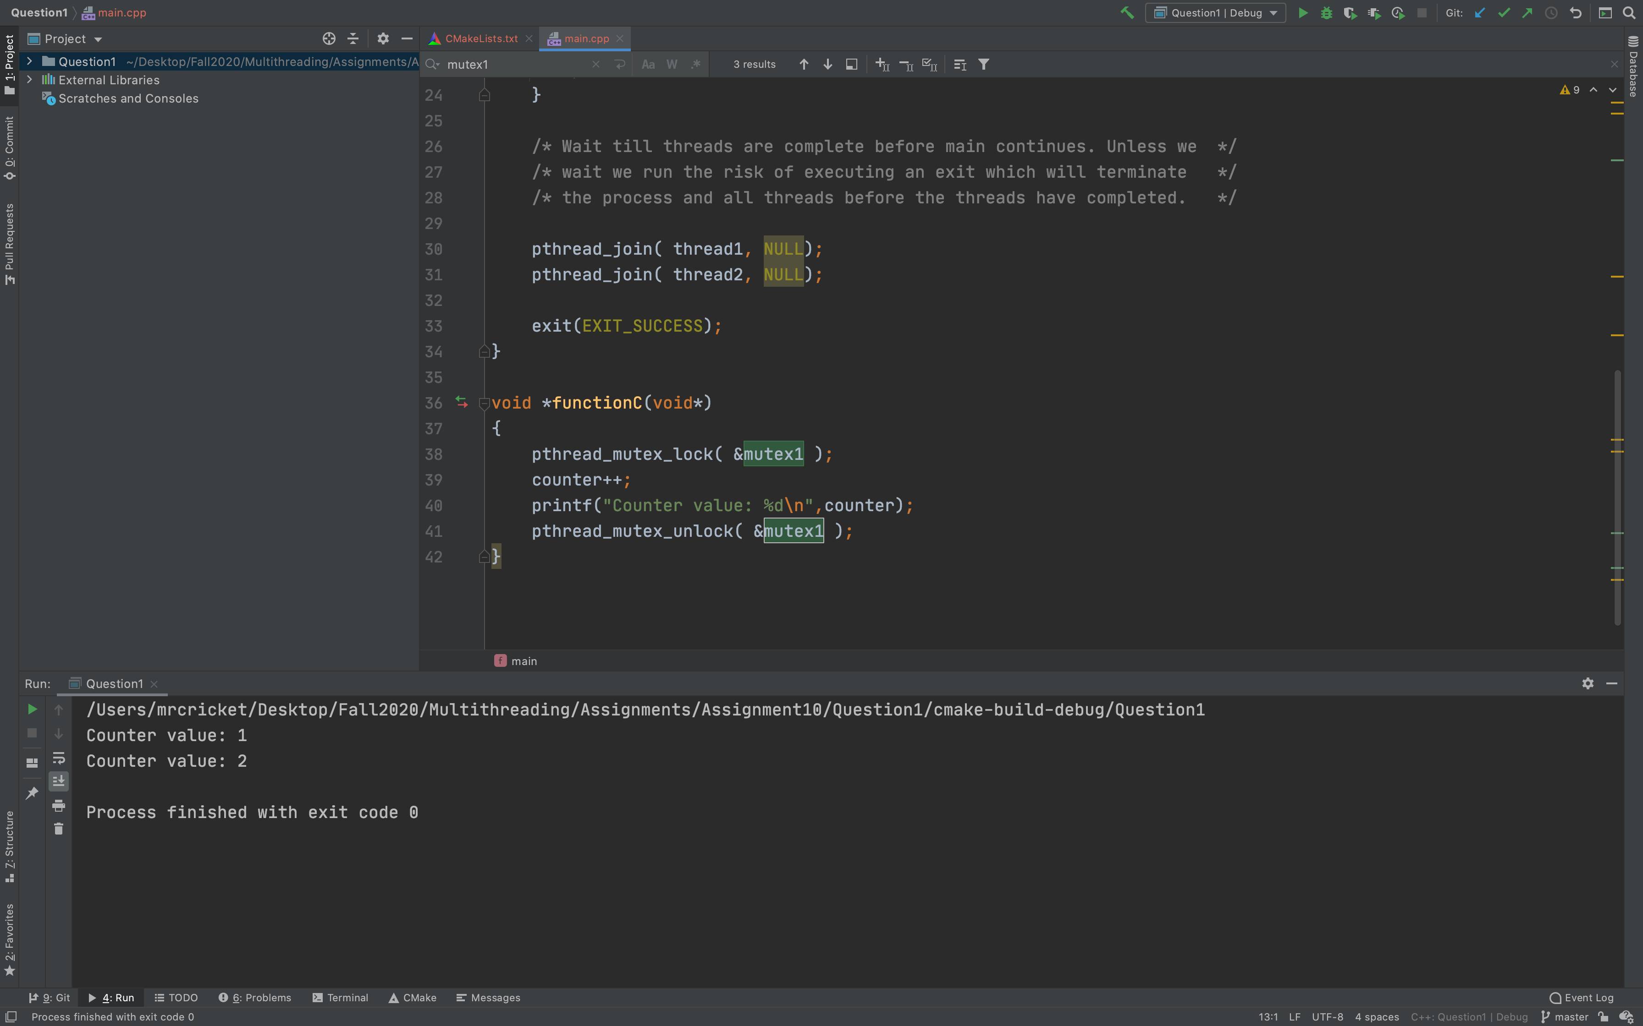

**2. This C++ program is similar to Java wait/notify using condition_variable library.**

**Compile and run this code, and explain how it works.**

**https://www.modernescpp.com/index.php/condition-variables**

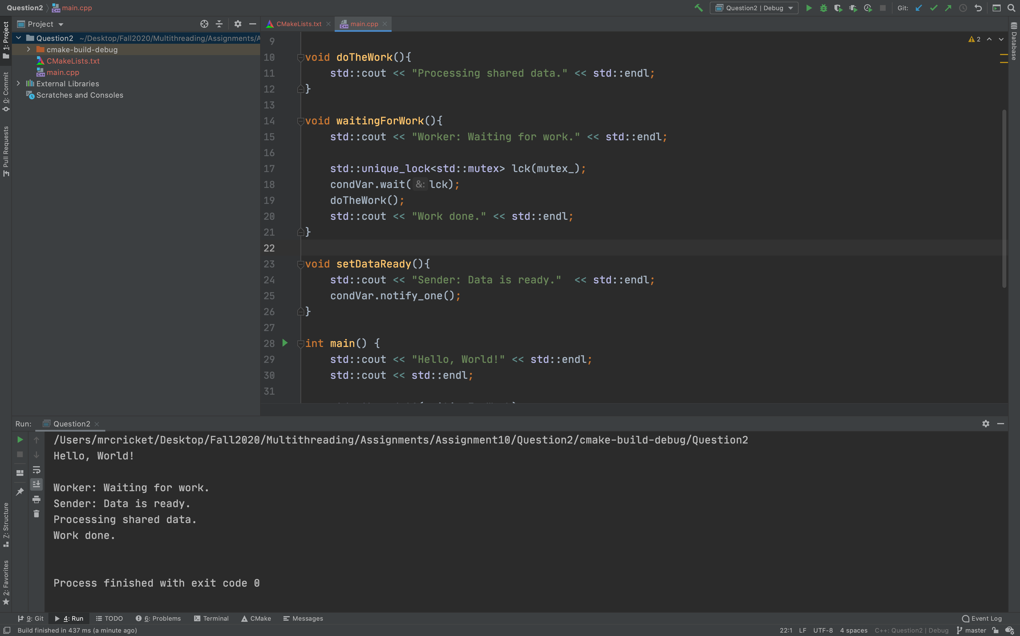

**Description**:

🡪The program has two child threads: **t1 and t2** and they get their callable payload (functions or functors**)**

**T1 🡪 waitingForWork**

**T2🡪 setDataReady.**

🡪The function **setDataReady notifies** using the **condition variable condVar** - that it is done with the preparation of the work: **condVar.notify_one().**

🡪While holding the lock, thread t2 is waiting for its notification: **condVar.wait(lck)**. The waiting thread always performs same steps.

**Spurious wakeup**

🡪 when the receiver **finished its task before the sender has sent its notification** then the receiver is susceptible for spurious wakeups. So the receiver wakes up, although no notification happens.

🡪 to avoid this situation we have created the boolean **variable dataReady**  used ,dataReady is set once data ready function called .

🡪 It is checked in the function **waitingForWork: condVar.waint(lck,[]return dataReady;}).** That's why **wait() method has** an additional overload which accepts a predicate. A predicate is a callable returning **true or false.**

Output : 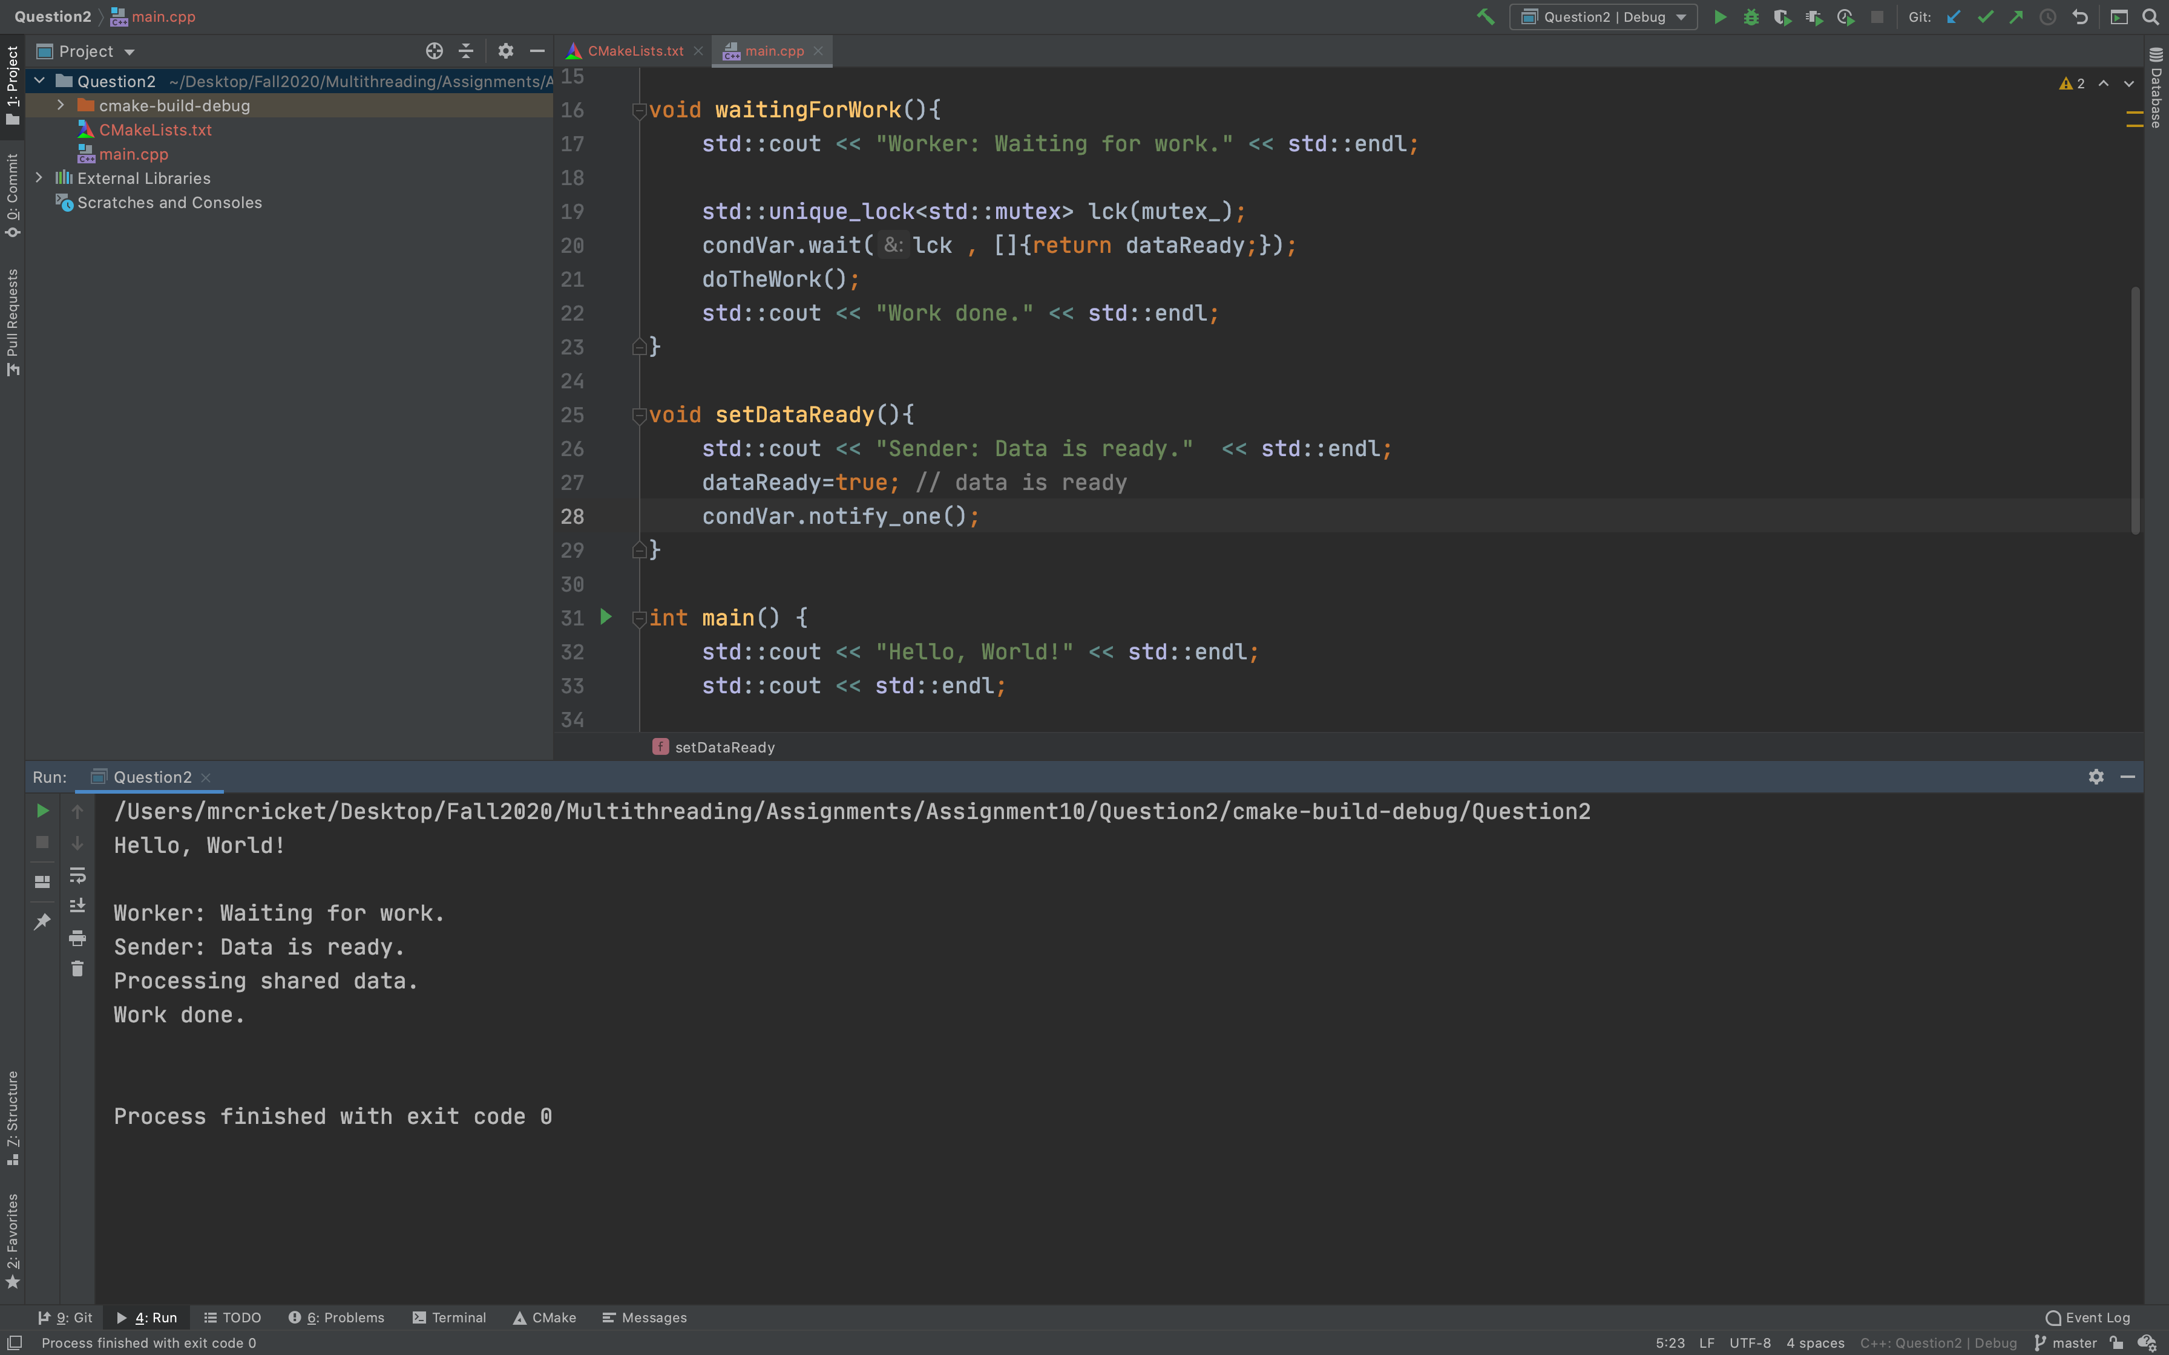

**Lost Wakeup**

🡪 if the sender sends its notification before the receiver gets to a wait state, notification gets lost.

🡪 The condition_variable class is a synchronization primitive that can be used to block a thread, or multiple threads at the same time, So the **notfication gets lost and the receiver is waiting and waiting and**.

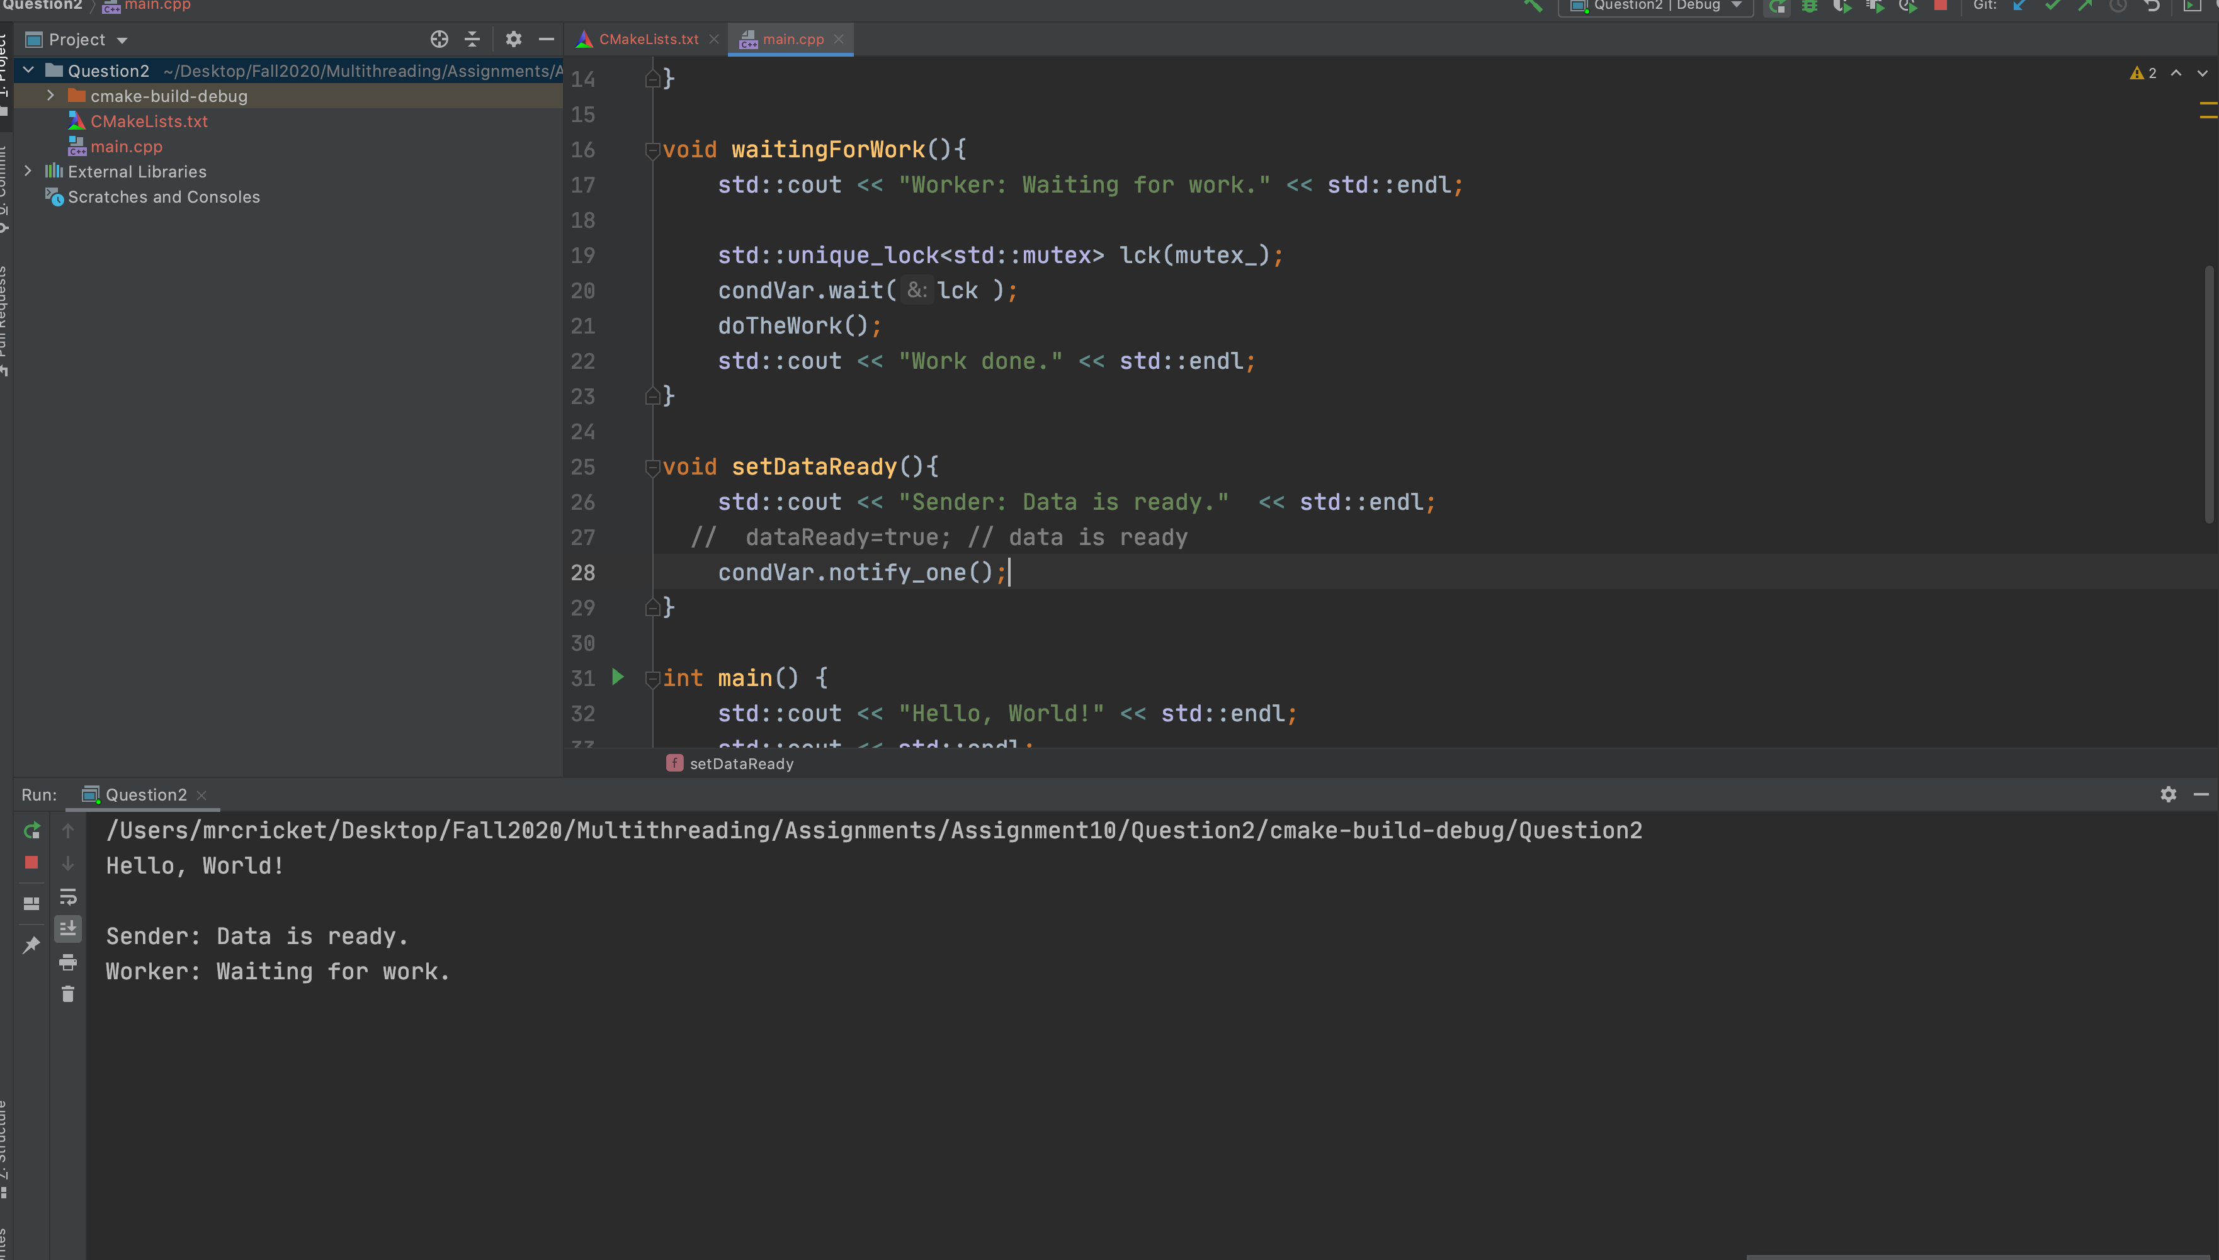

**3. This C/C++ program uses Mutex and Condition_variable library to manage three threads, the producer and two consumer threads. a) Read the code and Explain how all pieces work,**

**b) Compile and run the code, Explain outputs, c) Add two more consumer threads D and E to the program, compile and run the program.**

[**https://www.geeksforgeeks.org/sharing-queue-among-three-threads/**](https://www.geeksforgeeks.org/sharing-queue-among-three-threads/)

**Explanation:**

🡪 In given program we have two types of threads one is consumer and another is producer.

🡪 We have one producer thread which produce some data and keep pushing into the global queue

-🡪 On the other hand we have two different consumer threads which will poll the data from global queue

🡪 Consumer thread will perform summation of the whatever the data they have grabbed from the global queue

🡪At the end in main thread we compare the summation of both the thread and declare winner.

🡪 To avoid the blocking we have used the mutex locking mechanism to protect the global queue and we have used the condition variable to notify the other threads.

**Output for two consumer**

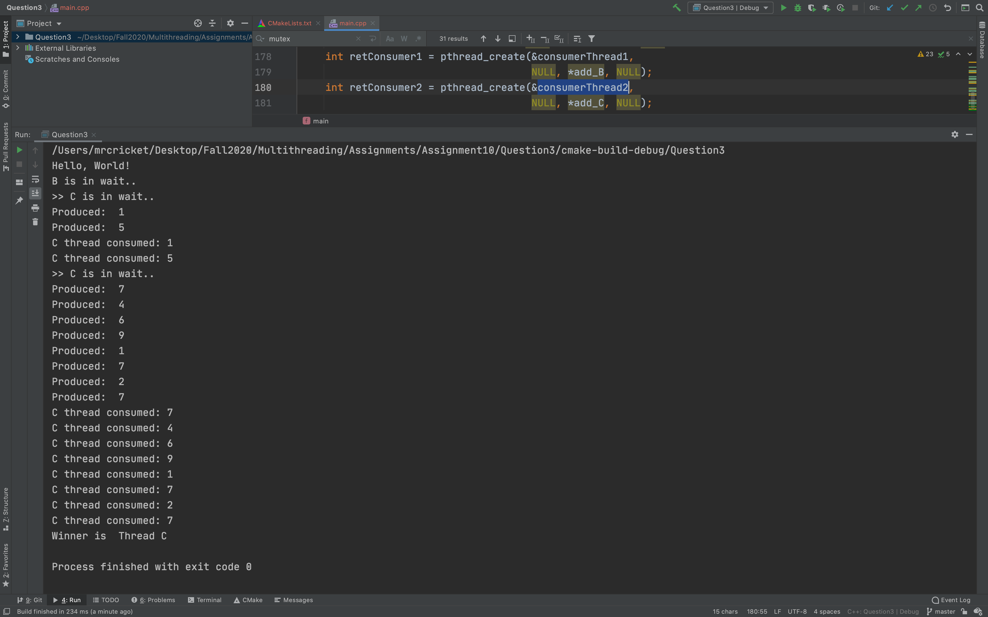

**Output using 4 consumers**

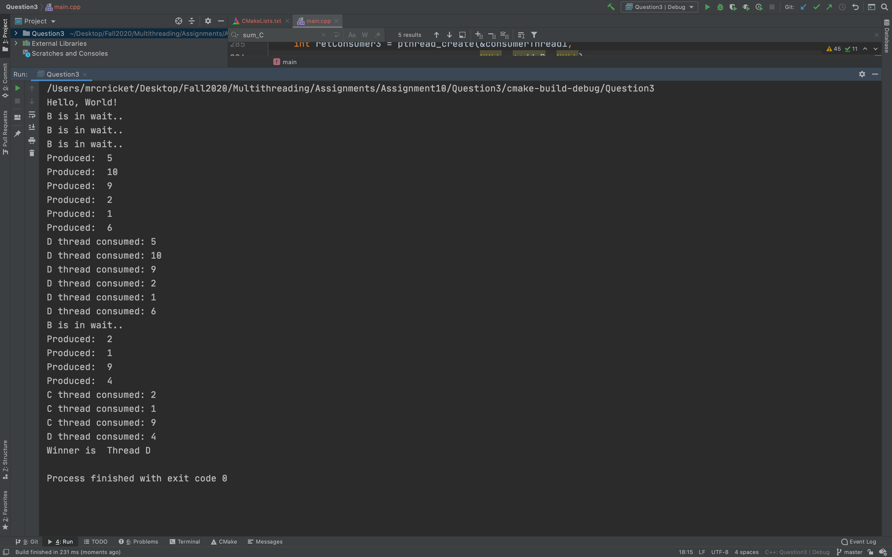

**4. The C++ Atomic library provides a set of operations, atomic_bool, atomic_short,**

**atomic_int, atomic_long, etc: http://www.cplusplus.com/reference/atomic/**

**a) Compile and run this program:**

**http://www.cplusplus.com/reference/atomic/atomic/atomic/**

**b) Change atomic_bool operation with atomic_short in this program.**

**c) Compile and run program.**

**a) Compile and run this program:**

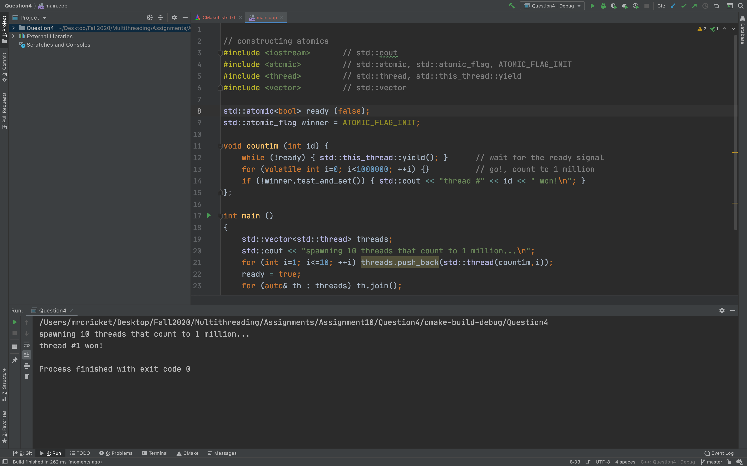

**b) Change atomic_bool operation with atomic_short in this program.**

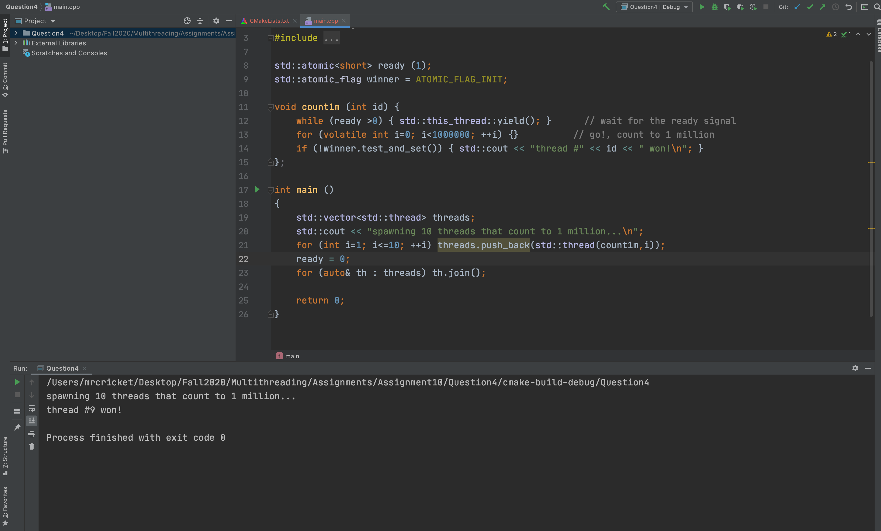

**c) Compile and run program.**

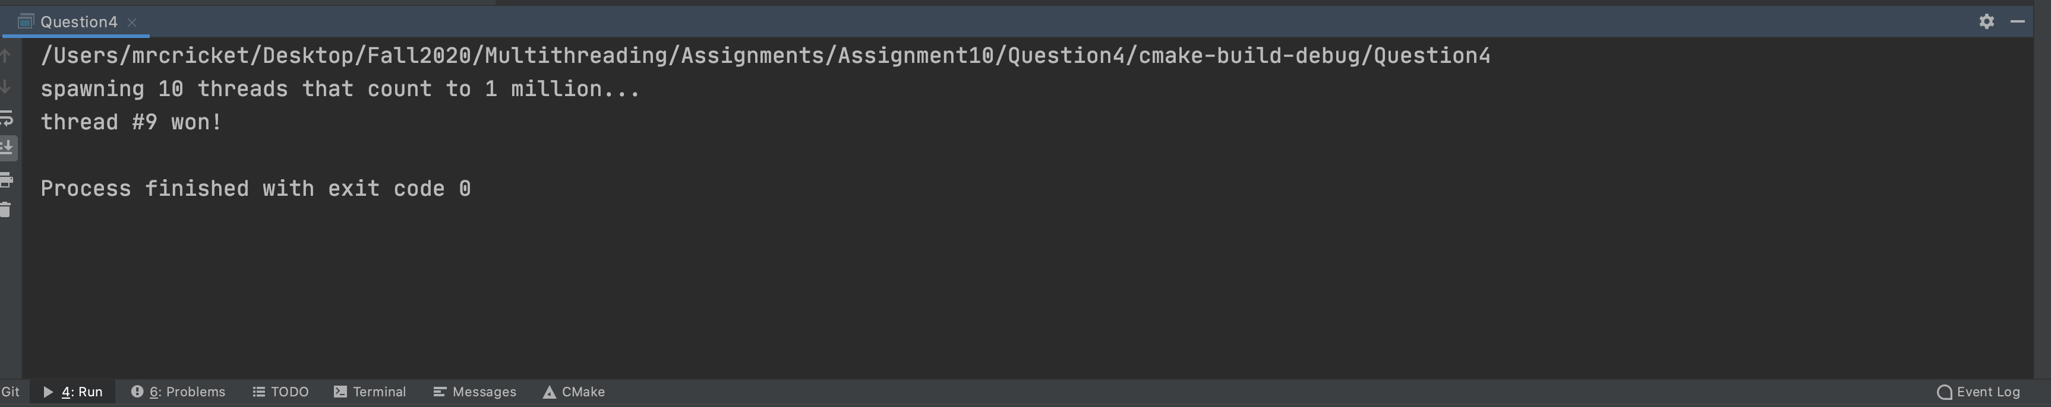

**5. Consider this Table data:**

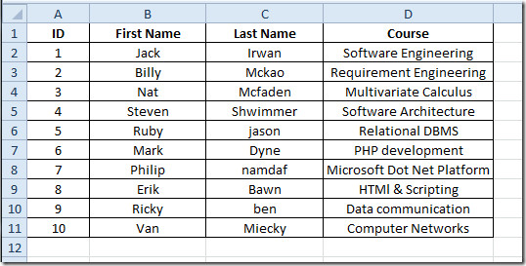

**A) Consider Stack with LinkedList C implementation:**

**http://btechsmartclass.com/data_structures/queue-using-linked-list.html**

1. **Compile and run code, Evaluate output**

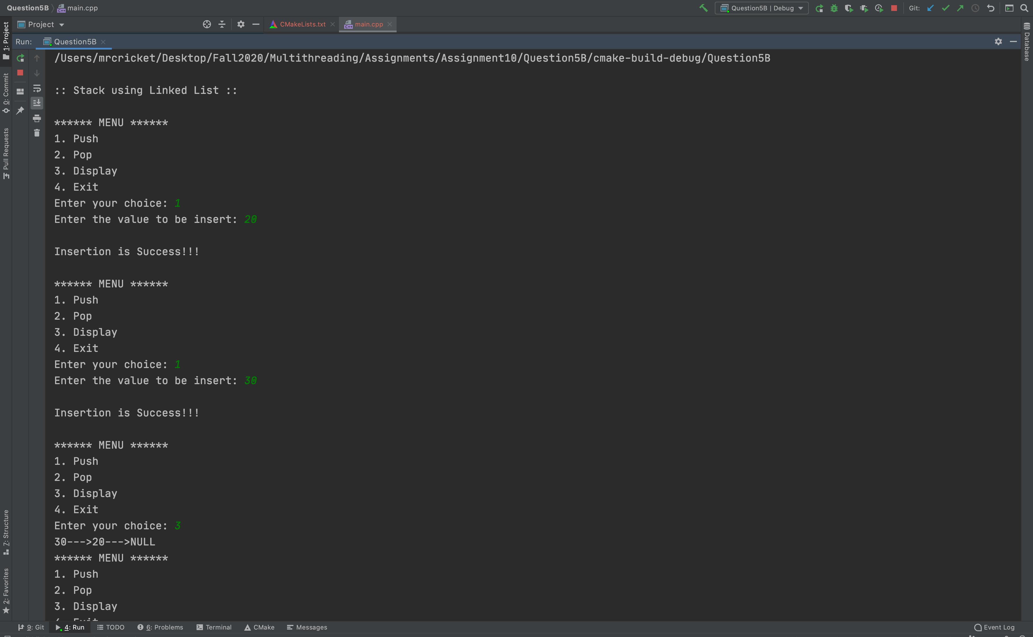

1. **Change struct Node to replace data with data presented in Table**

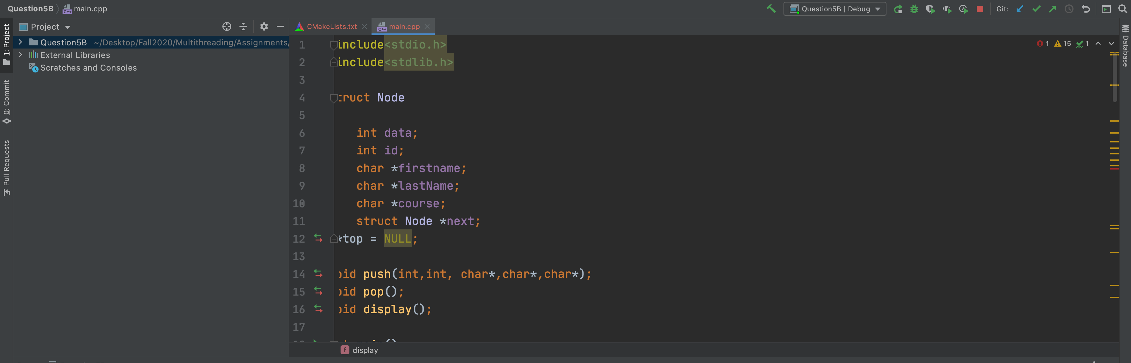

1. **Compile and run**

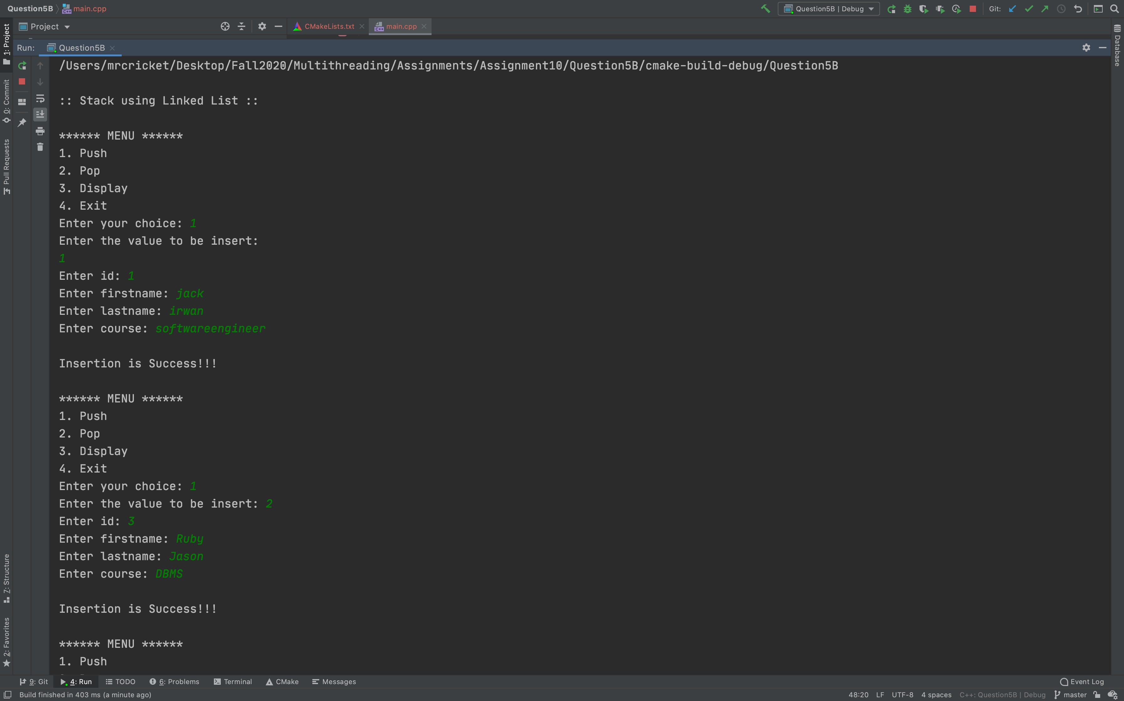

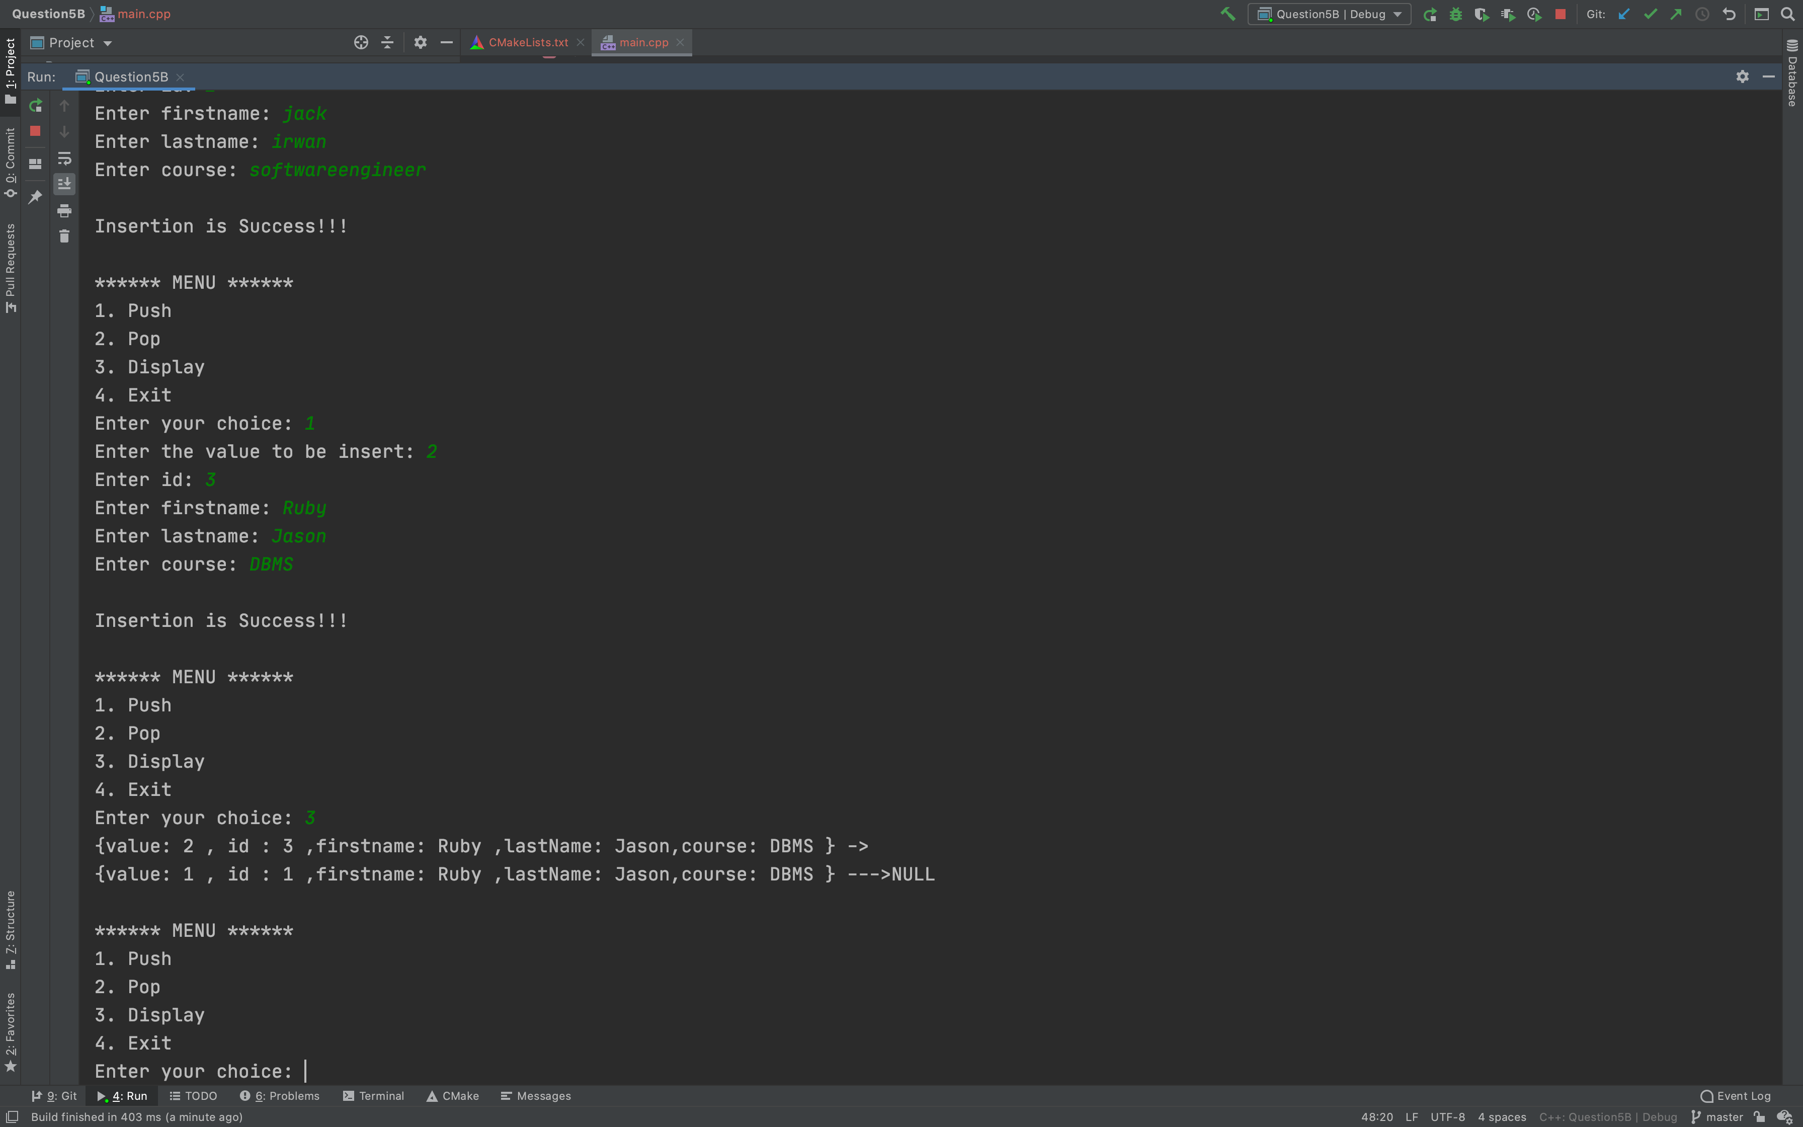

**B) Consider Queue with LinkedList C implementation:**

**http://btechsmartclass.com/data_structures/queue-using-linked-list.html**

**a) Compile and run the code and Evaluate output**

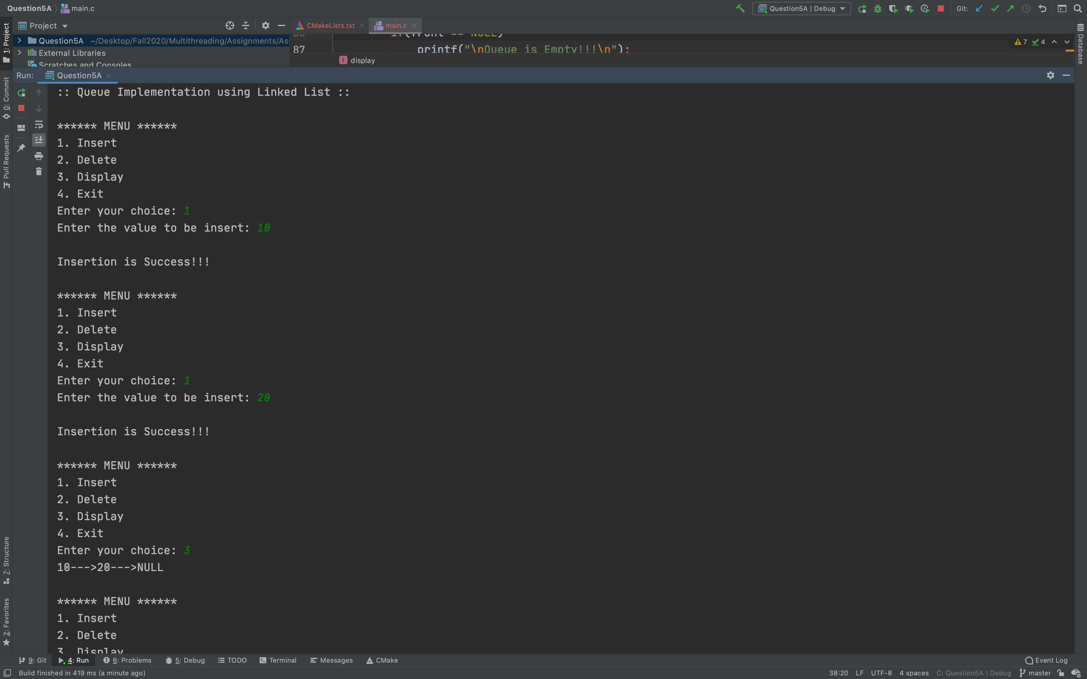

**b) Change struct Node to replace data with data presented in Table**

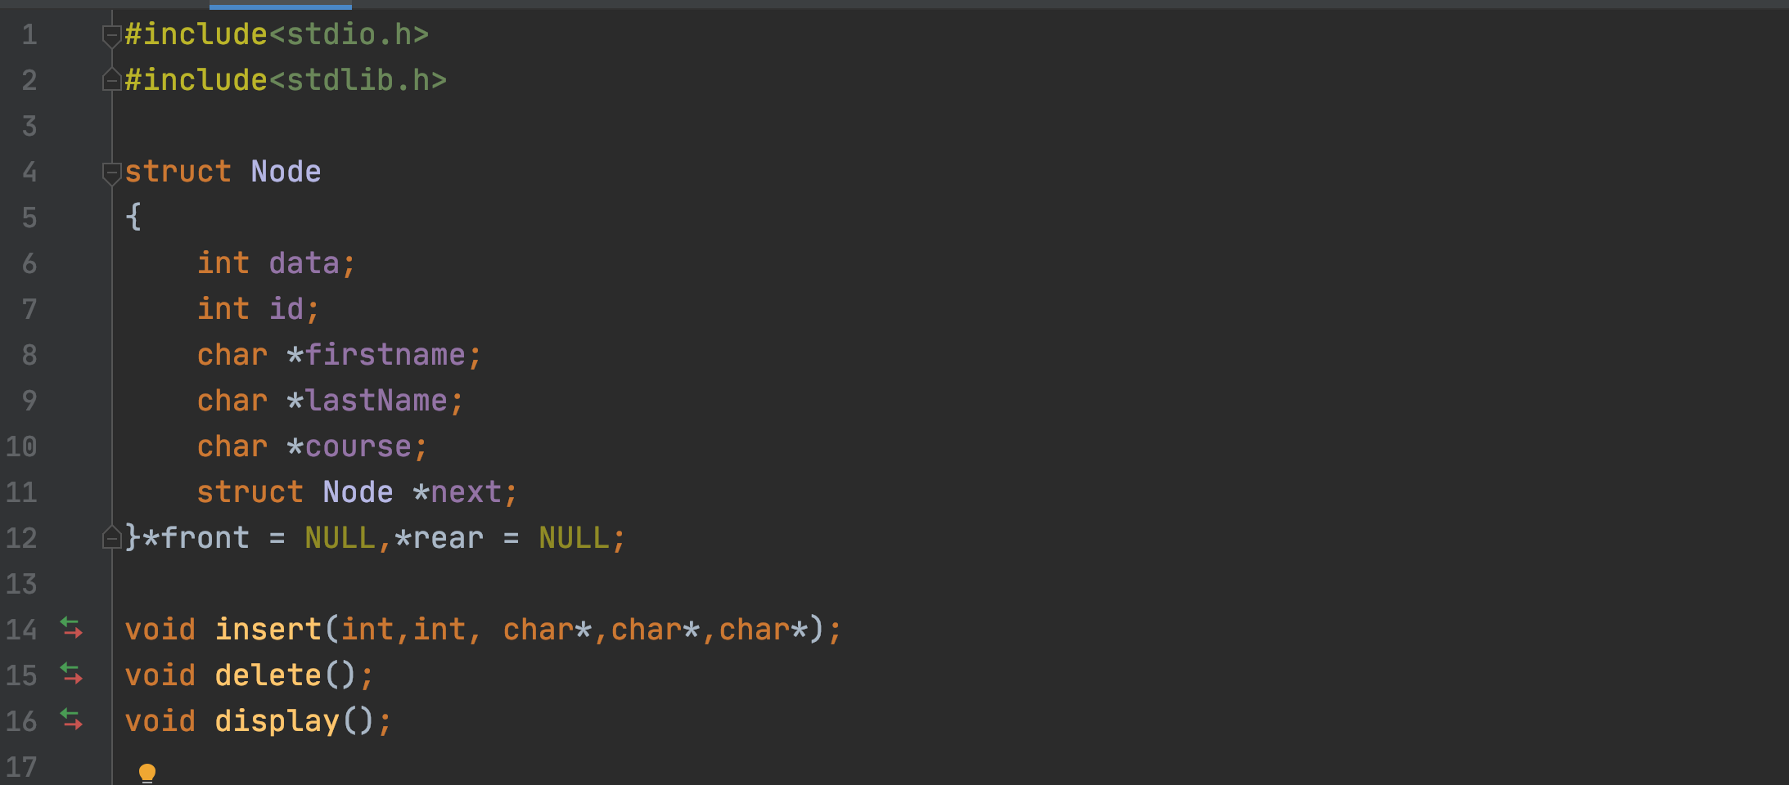

1. **Compile and run**

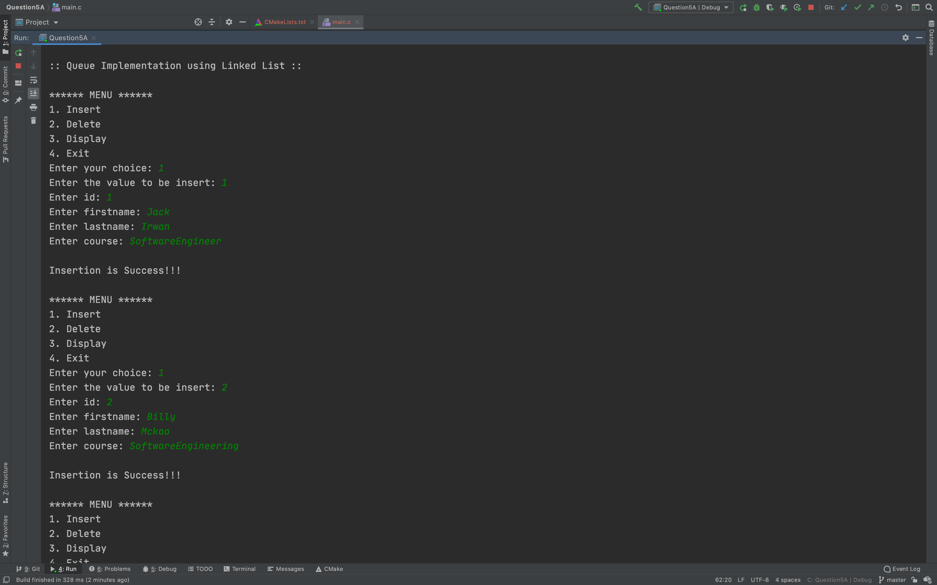

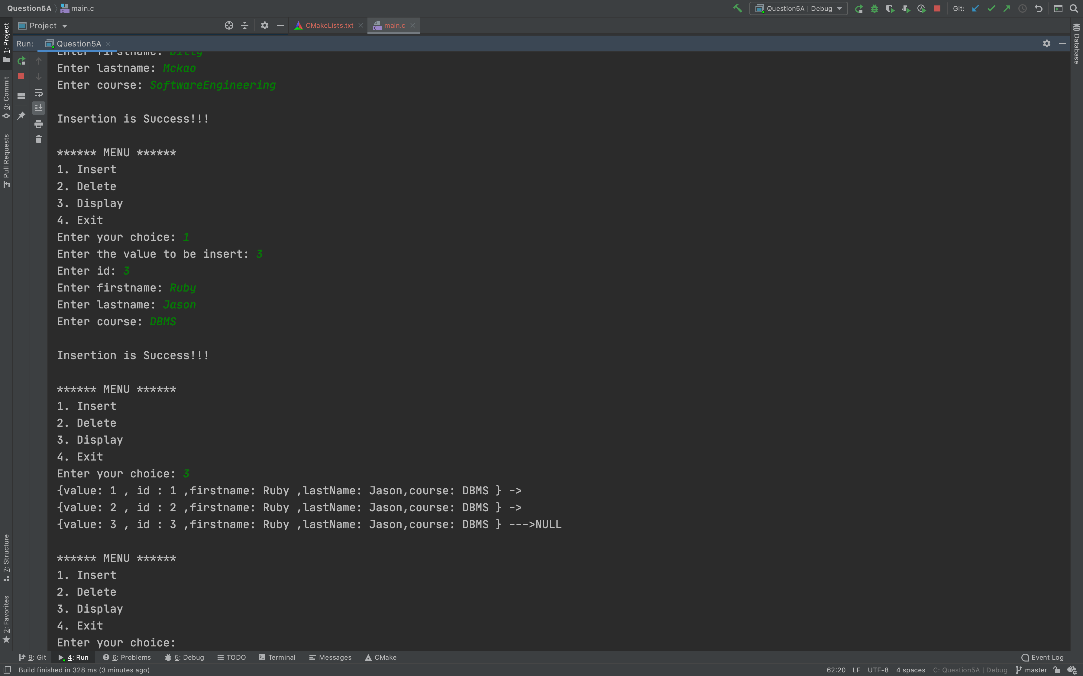

6. Define a Student class with instance variables name, id, homework, midterm, and final-exam. Name is a string whereas others are all integers. Also add a static variable nextId which is an integer and statically initialized to 1. In each of them, the id should be assigned to the next available id given by nextId. The default constructor should set the name of the student object to “StudentX” where X is the next id.

A) Your program is to create 50 Student Threads each to be identified with name-Thread-nextId. The default constructor for each thread calls a method to randomly generate grades for homwork, midterm, and final-exam ranging between 70 to 100 inclusive. You need to consider 1 second wait-time between each score generation for homework, midterm, and final-exam. Each student thread writes the grade scores to “Grades” file in this format: name, nextId, ThreadId, homework, midterm, finalExam. All student threads share this file and you need to protect it.

B) Create GraderThread that checks “Grades” file periodically up to 20 seconds to retrieve submitted grades by all student threads. How do you protect this file? The GraderThread reads the file (format described above) and validates name, id, threadId, scores for all 50 student threads submitted scores. For any missing grade, the student will receives zero score. The GraderThread does calculateGrade() (50% homework, 30% midterm + 20% final) and returns a letter grade like “A”, “B”, “C”, “D” or “F”, based on overall score.

C) Create GradesTestDriver class to create 50 Threads, 100 Threads, 150 Student Threads and

one GraderThread to test your program.

D) Answer the following questions:

a) Write this program with Java and then with C++

b) Use Explicit Locking for both Java and C++

c) Evaluate the code Performance between Java and C++

d) Report Results with all performance differences

e) Discuss as to why one performance is better than the other

**Approach in JAVA:**

🡪 As per the requirement I have created the student class with all the student details and implements the runnable thread.

🡪 Create Function to generate the random number between 70 to 100 and set the all the score attribute.

🡪 Create grader class and implement runnable thread and in run method continuously check for the grade.

🡪 Create a util class to handle insert and read the data from the file and protect the util object using explicit locking mechanism.

🡪 Create the GradesTestDriver class to generate different no of student threads.

🡪 For more detail please check the attached solution file

**Approach in C++:**

🡪 As per the requirement I have created the student class with all the student details

🡪 Create Function to generate the random number between 70 to 100 and set the all the score attribute.

🡪 Create the grader thread inside the main method and call the grader method to check the updated grade from the file

🡪 To protect the file I have use the mutex lock mechanism .

🡪 For more detail please check the attached solution file

**Java Output:**

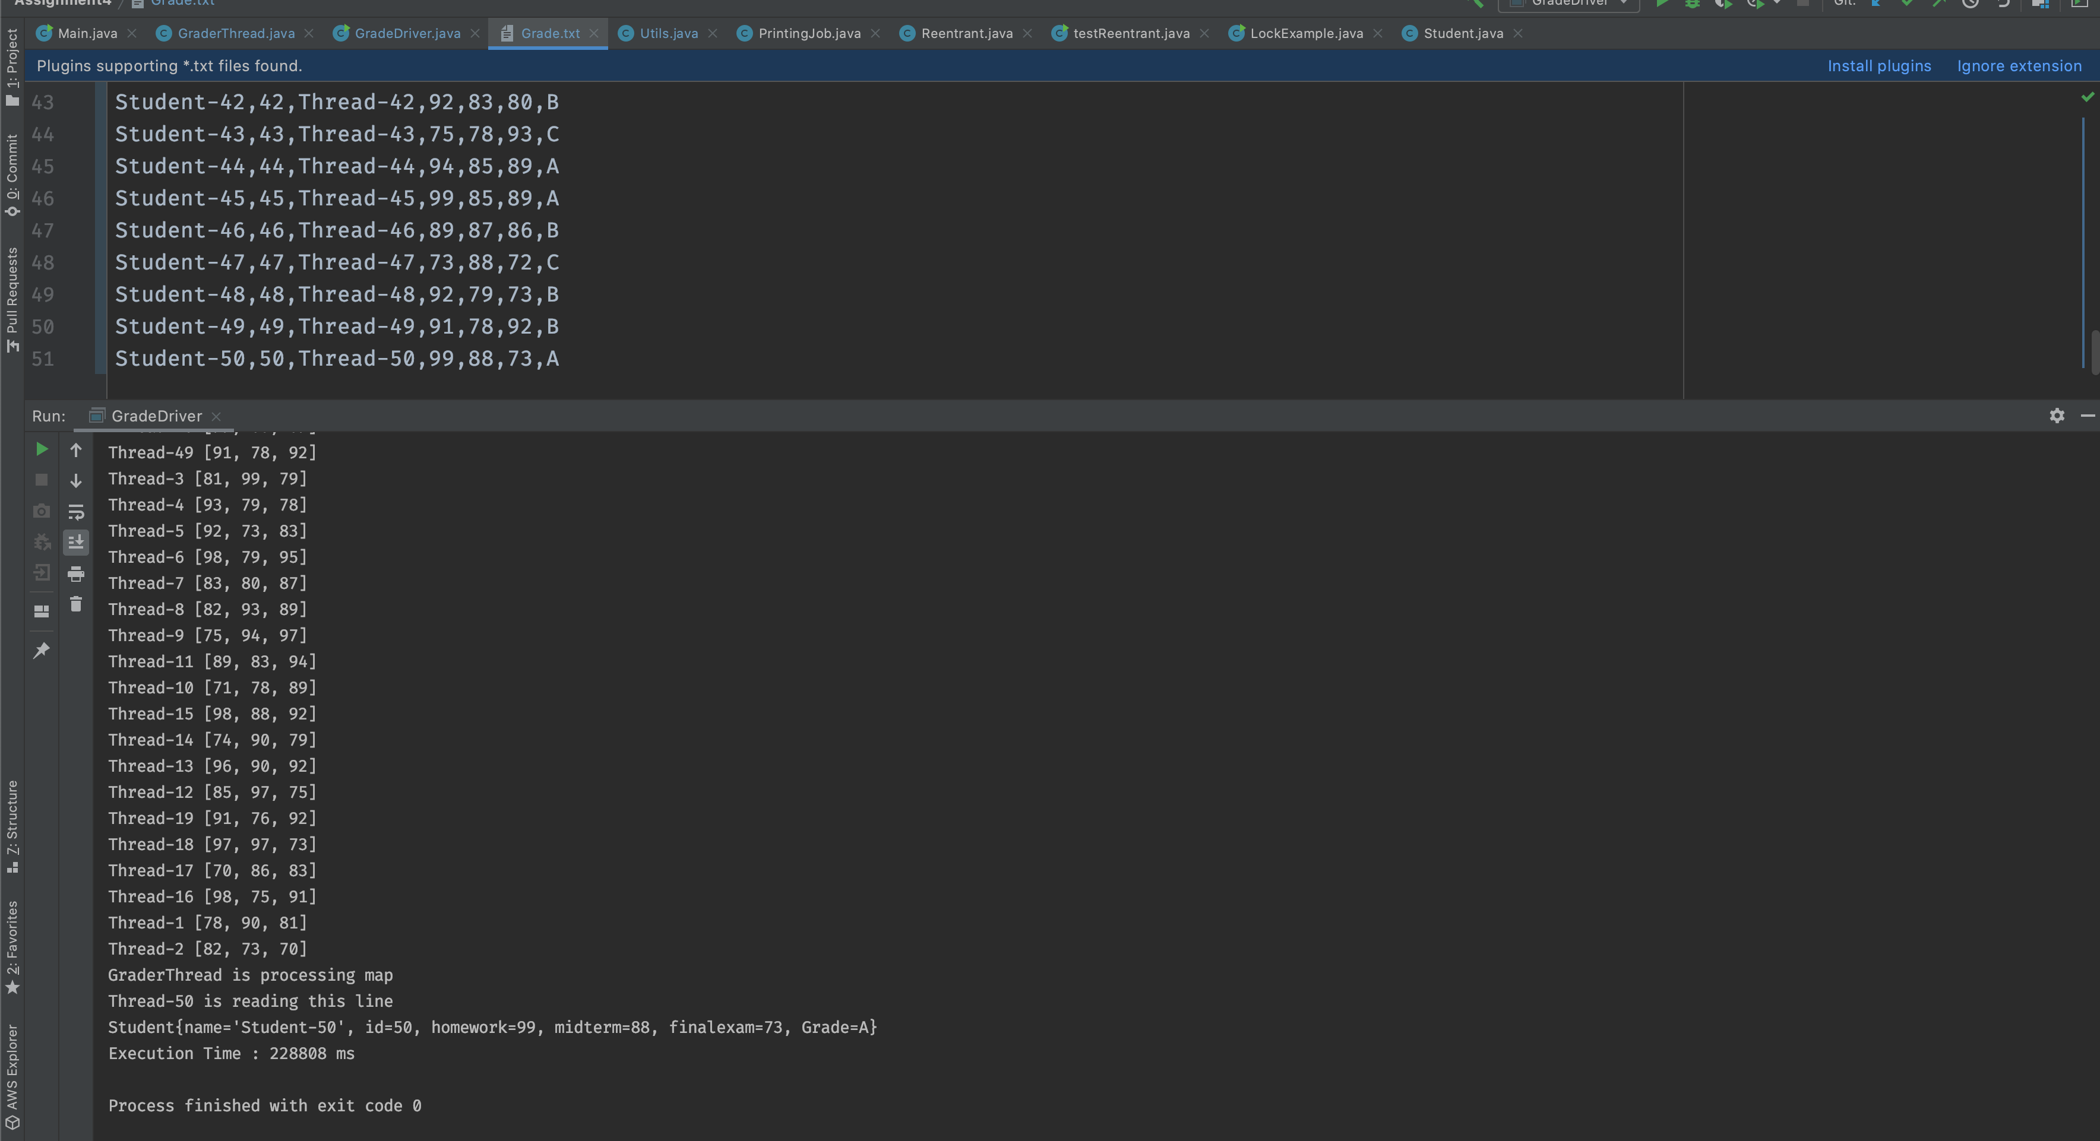

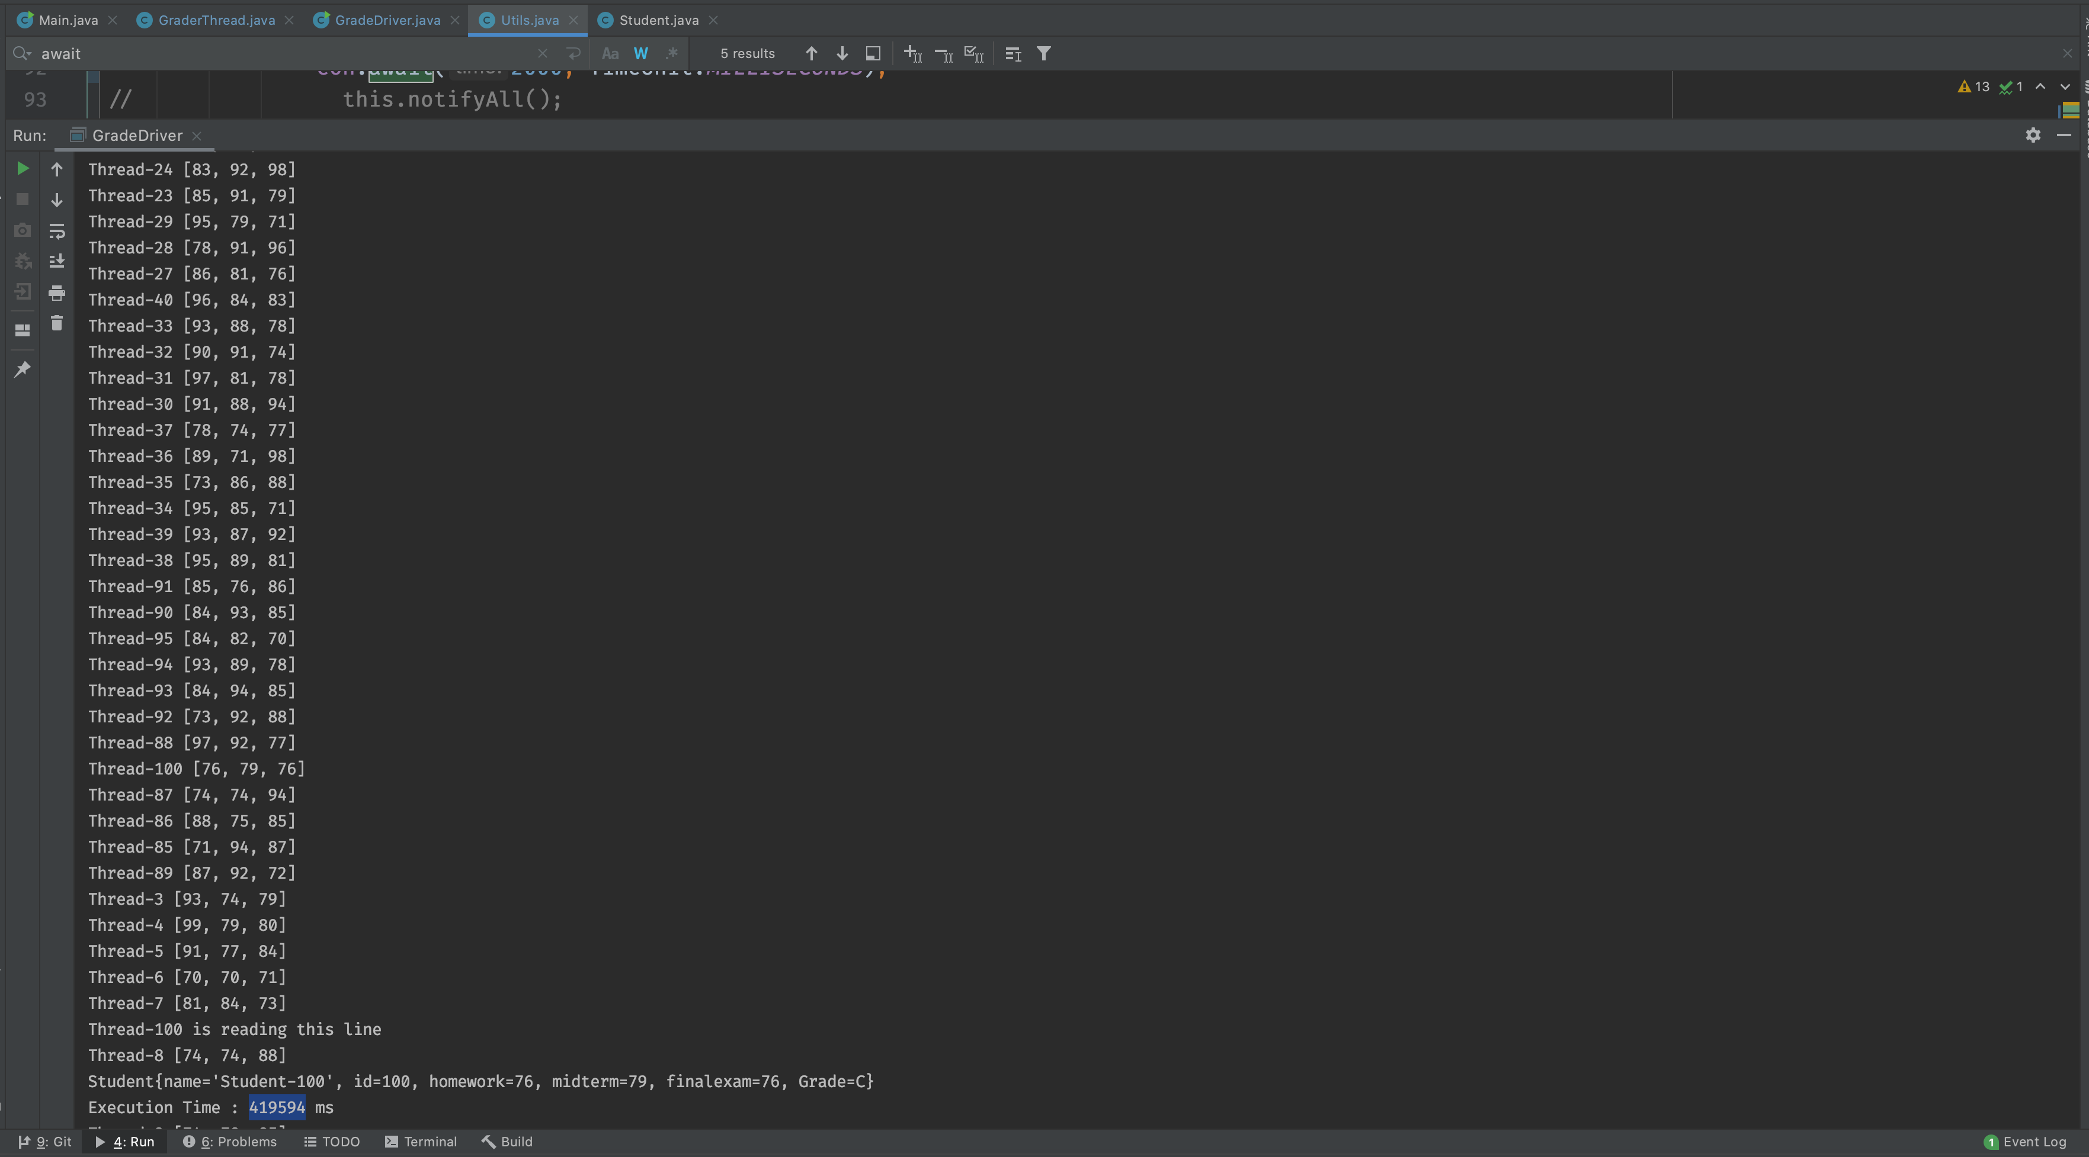

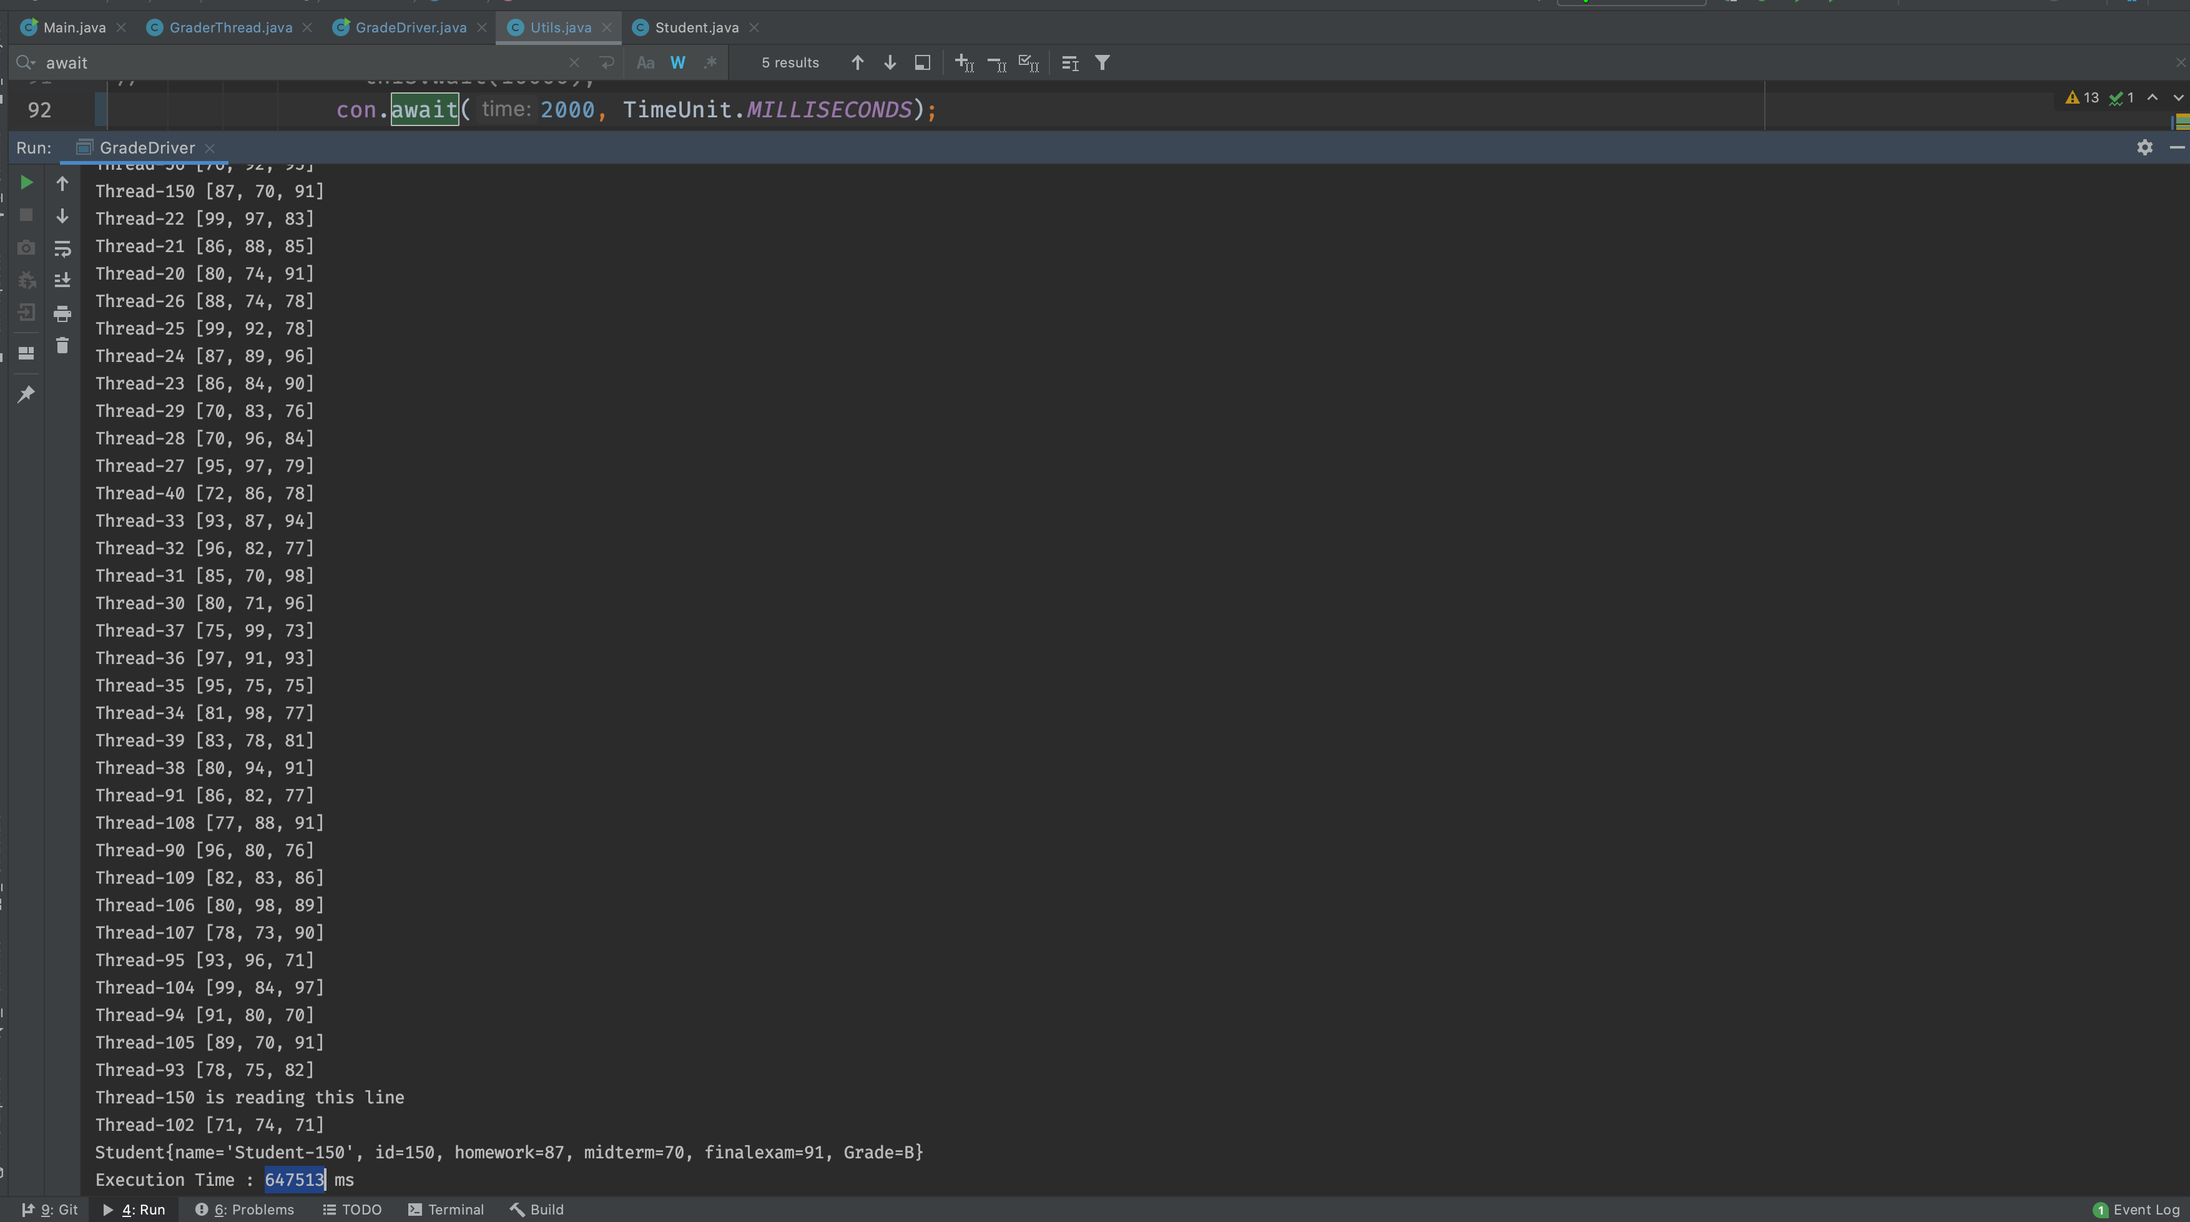

**C++ Output**

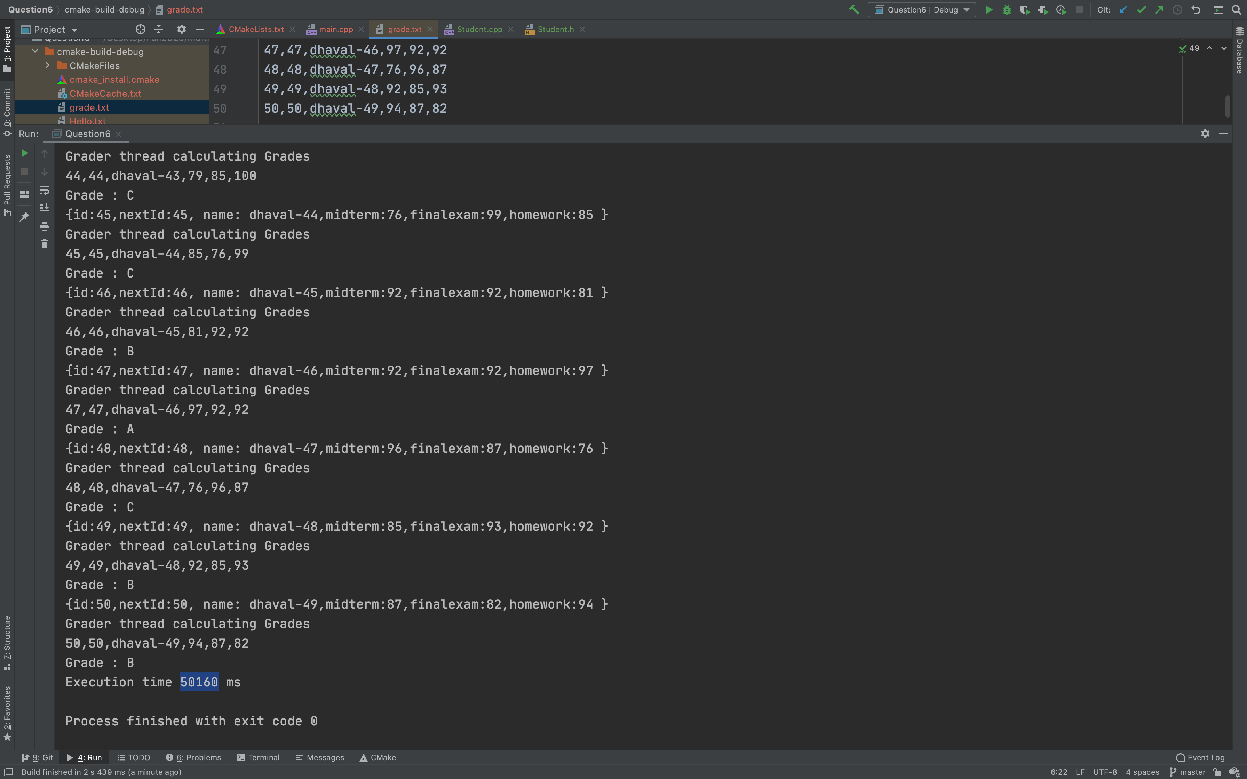

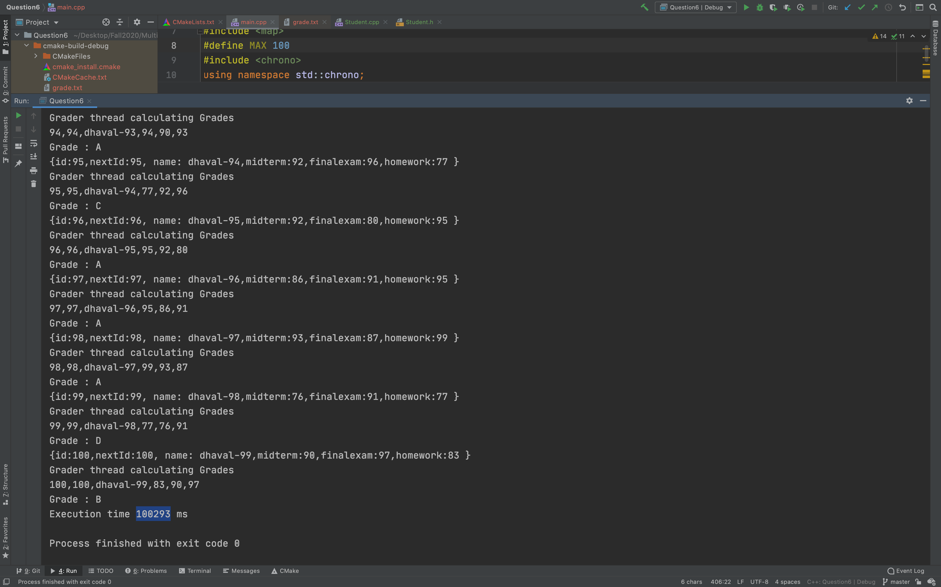

**Performance table**

|  |  |  |  |
| --- | --- | --- | --- |
| **Language** | **Time for 50 Threads**  **(ms)** | **Time for 100 Threads**  **(ms)** | **Time for 150 Threads**  **(ms)** |
| Java | 228808 | 419594 | 647513 |
| C++ | 50160 | 100293 | 150433 |

**why one performance is better than the other**

🡪 From the above performance table we can clearly see that threading c++ is much faster than java.

🡪 We know that the java is **interpreted language** that means code is compiled into an intermediary form before it is converted into machine code. In Java, this intermediary is called bytecode. At runtime, a Java virtual machine (JVM) turns this bytecode into machine code, and it's the machine code that runs on the processor.

🡪 On the other end C++ gets **compiled directly into machine code** -- without an intermediary translation required at runtime. This is one reason why C++ programs tend to perform faster than those written in Java.

🡪 Other major difference is in **java memory management done by garbage collection** The main problem with a GC is that while on average a garbage collector performs better, **we lose some control over when to take the performance cost**.

🡪 While in C++ we **are managing memory manually so we ensures our thread won't ever be halted while waiting for memory to be cleaned up**.

**7. Consider the following code pieces to build Native Threads to Complete missing code pieces, compile and run:**

**https://devarea.com/java-and-cc-jni-guide/#.X7py19NKhR3**

static jlong fibNR(JNIEnv *env, jclass clazz, jlong n) {

pthread_t t1;

pthread_create(&t1,NULL,**threadfn**,(void*)n);

return 0;

}

static void \***threadfn**(void *p)

{

jlong res = longlastfn((long)p);

JNIEnv *env;

int n=javaVM->**AttachCurrentThread(&env,NULL); // env created for each thread**

**Attach env to access the function**

// use env to access any function

javaVM->DetachCurrentThread();

return (void*)res;

}

static jlong fibNR(JNIEnv *env, jclass clazz, jlong n) {

pthread_t t1;

pthread_create(&t1,NULL,threadfn,(void*)n);

return 0;

}

JavaVM *vm;

env->GetJavaVM(&vm);

**Code Explanation**

🡪 In given code we are trying to create a thread in the native code. To create thread we have used pthread_create function and pass pointer to function name **threadfn** and parameters (**void*)n**

🡪 the parameter env is created for each thread and if you want to use it on a custom thread you need to create one by using **AttachCurrentThread method.**

🡪At the end we are **accessing javaVM by saving it as a global variable in JNI_OnLoad** or **retrieving it from env on the function that creates the thread.**

**8. Consider the following code pieces, work correctly? If not how would you fix it?**

A)

int *getPtrToFive() {

int *x = new int;

*x = 5; return x;

}

int main() {

int *p;

for (int i = 0; i < 3; ++i) {

p = getPtrToFive();

cout << *p << endl;

}

delete p;

}

**Explanation**

🡪 In given cod snippet we are de-allocating the space using delete method outside the for loop hence it will de-allocate the space of last variable.

🡪 To de-allocate the space of all the variable we should include the delete inside the for loop.

for (int i = 0; i < 3; ++i) {

p = getPtrToFive();

cout << *p << endl;

**delete p**;

}

B)

int main() {

int numItems;

cout << "how many items? ";

cin >> numItems;

int *arr = new int[numItems];

for (int i = 0; i < numItems; ++i) {

cout << "enter item " << i << ": ";

cin >> arr[i];

}

for (int i = 0; i < numItems; ++i) {

cout << arr[i] << endl;

}

delete[] arr;

}

**Explanation**

🡪 In given code snippet we are creating variable size array by getting size from user.we gets the user input to store the data in that array

🡪 At the end we are de-allocating memory using **delete[] arr**

C)

class IntegerArray {

public: int *data;

int size;

IntegerArray(int size) {

data = new int[size];

this->size = size;

}

~IntegerArray() {

delete[] data;

}

};

int main() {

IntegerArray a(2);

a.data[0] = 4;

a.data[1] = 2;

if (true) {

IntegerArray b = a;

}

cout << a.data[0] << endl; // not 4!

}

**Explanation**

🡪 In Given code snippet default copy constructor copies fields an point it to first element of an array

🡪Inside the main method when b goes out of scope, destructor is called (deallocates array), a.data now **a dangling pointer** after that when a goes out of scope, its destructor tries to delete the (already-deleted) array

To correct this problem we can write our own copy constructor to copy all the elements

**IntegerArray(IntegerArray &o) {**

**data = new int[o.size];**

**size = o.size;**

**for (int i = 0; i < size; ++i)**

**data[i] = o.data[i];**

**}**

**9. Consider the following code segments describe the design of non-blocking Algorithms for Stack and Queue data structures. Explain step-by-step how each case works: a) non-blocking Algorithm Stack, b) non-blocking QueueLinkedList show how steps A, B, C, D wo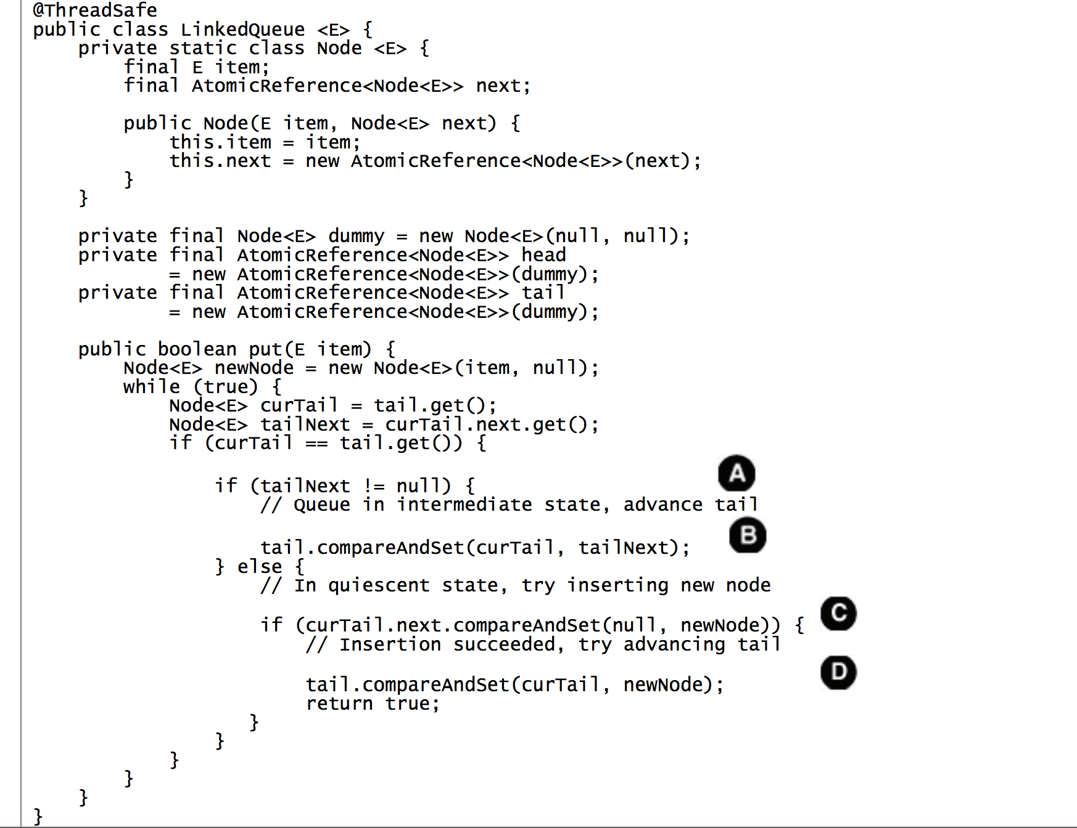rk**

**a) non-blocking Algorithm Stack**

🡪 In the concurrent stack **push** method prepares a new link node whose next field refers to the current top of the stack, and then uses **CAS** to try to install it on the top of the stack.

🡪 If the **same node is still on the top of the stack as when we started, the CAS succeeds**; if the top node has changed may be because another thread has added or removed elements since we started, the CAS fails and push updates the new node based on the current stack state and tries again. In either case, the stack is still in a consistent state after the CAS

🡪 Same thing we are doing for POP operation

**b) non-blocking QueueLinkedList show how steps A, B, C, D work**

**🡪 in the Concurrent LinkedQueuein step A** first we are checking that if the queue is in the intermediate state before attempting to insert a new element **,**If it is, then some other thread is already in the process of inserting an element (between its steps C and D).

🡪 In **step B** Rather than wait for that thread to finish, the current thread helps it by finishing the operation for it, **advancing the tail pointer** and  **repeats this check in case another thread has started inserting a new element, advancing the tail pointer until it finds the queue in the quiescent state so it can begin its own insertion**.

🡪 **In Step C** we are performing CAS, which **links the new node at the tail of the queue**, **could fail if two threads try to insert an element at the same time.** In that case, no harm is done: no changes have been made, and the current thread can just reload the tail pointer and try again. Once C succeeds, the insertion is considered to have taken effect.

🡪 **In Step D** we are performing CAS for “Cleanup”**,** since it can be performed either by the inserting thread or by any other thread. If D fails, the inserting thread returns anyway rather than retrying the CAS, because no retry is needed

